Carola Diaz Aizpun
21/01/19
REGRESIÓN PEC 2
UOC
Ejercicio 1

Las columnas del archivo contienen el número del sujeto, la edad, el sexo, el tiempo desde la fecha de reclutamiento, el UPDRS motor, el UPDRS total y 16 medidas de voz biomédicas. Cada fila corresponde a una de las 5875 gravaciones de voz de estos individuos. El principal objetivo es predecir el UPDRS total a partir de las 16 medidas de voz.

> import.data <-"http://archive.ics.uci.edu/ml/machine-learning-databases/parkinsons
+ /telemonitoring/parkinsons_updrs.data"
> parkinson <- read.table(url(import.data), sep=",", skip=1)
> names(parkinson) <- c("subject#","age","sex","test_time","motor_UPDRS","total_UPDRS",
+ "Jitter(%)","Jitter(Abs)","Jitter:RAP","Jitter:PPQ5","Jitter:DDP",
+ "Shimmer","Shimmer(dB)","Shimmer:APQ3","Shimmer:APQ5","Shimmer:APQ11",
+ "Shimmer:DDA","NHR","HNR","RPDE","DFA","PPE"
+ )
> set.seed(123)

A continuación separamos la base de datos en dos grupos: el grupo data.train con el 80 % de las observaciones y el grupo data.test con el resto. La base de datos data.train servirá para calcular los diferentes modelos y la base de datos data.test para comprobar el ajuste a un grupo externo de datos.

> data.test<- parkinson
> data.train<- data.test[1:4664,]

Para evitar problemas es mejor que suprimamos de entrada las observaciones con valores perdidos, si los hay

> sapply(data.test, function(x) sum(is.na(x))
+ )
subject# age sex test_time motor_UPDRS total_UPDRS
0 0 0 0 0 0
Jitter(%) Jitter(Abs) Jitter:RAP Jitter:PPQ5 Jitter:DDP Shimmer
0 0 0 0 0 0
Shimmer(dB) Shimmer:APQ3 Shimmer:APQ5 Shimmer:APQ11 Shimmer:DDA NHR
0 0 0 0 0 0
HNR RPDE DFA PPE
0 0 0 0

Vemos como no hay valores perdidos en ninguna de las columnas.

Utilizar la puntuación total_UPDRS como variable respuesta y las 16 medidas de voz como potenciales regresoras. Se trata de estudiar el mejor modelo por diferentes métodos. En cada caso se informará delnúmero de variables (o componentes) que se utilitzan, el coeficiente R2 ajustado (cuando se pueda) y el root mean squared error (RMSE) para el grupo de ajuste (train ) y para el grupo de prueba (test ).

Ajustar los siguientes modelos:
1. Regresión lineal con todas las 16 variables predictoras.
Indicar los posibles problemas, que no consideramos, al prescindir del factor “sujeto”.

- Variables predictoras utilizadas: 16 en cambos casos
- R2 ajustado train= 0.1624
- R2 ajustado total= 0.09811
- RMSE train=
> RSS <- c(crossprod(modelo1$residuals))
> MSE <- RSS / length(modelo1$residuals)
> RMSE <- sqrt(MSE)
[1] 9.105571
- RMSE total= [1] 10.14711

> modelo1 <- lm(total_UPDRS ~ Jitterp + Jitterabs + Jitterrap + JitterPPQ5 + JitterDDP + Shimmer + ShimmerdB + ShimmerAPQ3 + ShimmerAPQ5 + ShimmerAPQ11 + ShimmerDDA + NHR + HNR + RPDE + DFA + PPE, data = data.train)
> summary(modelo1)

Call:
lm(formula = total_UPDRS ~ Jitterp + Jitterabs + Jitterrap +
JitterPPQ5 + JitterDDP + Shimmer + ShimmerdB + ShimmerAPQ3 +
ShimmerAPQ5 + ShimmerAPQ11 + ShimmerDDA + NHR + HNR + RPDE +
DFA + PPE, data = data.train)

Residuals:
Min 1Q Median 3Q Max
-26.8633 -6.7371 -0.8759 6.7436 25.2467

Coefficients:
Estimate Std. Error t value Pr(>|t|)
(Intercept) 6.029e+01 3.114e+00 19.359 < 2e-16 ***
Jitterp 9.891e+00 2.465e+02 0.040 0.96800
Jitterabs 9.074e+03 1.067e+04 0.851 0.39502
Jitterrap -4.865e+03 4.918e+04 -0.099 0.92121
JitterPPQ5 -1.872e+01 2.782e+02 -0.067 0.94636
JitterDDP 1.770e+03 1.640e+04 0.108 0.91402
Shimmer -4.303e+01 1.001e+02 -0.430 0.66733
ShimmerdB -9.911e-01 5.667e+00 -0.175 0.86117
ShimmerAPQ3 -8.787e+04 4.947e+04 -1.776 0.07577 .
ShimmerAPQ5 5.041e+01 8.529e+01 0.591 0.55456
ShimmerAPQ11 1.219e+02 3.797e+01 3.211 0.00133 **
ShimmerDDA 2.924e+04 1.649e+04 1.773 0.07626 .
NHR -7.617e+01 1.001e+01 -7.611 3.27e-14 ***
HNR -4.974e-01 7.217e-02 -6.891 6.28e-12 ***
RPDE 1.961e+01 1.936e+00 10.129 < 2e-16 ***
DFA -5.317e+01 2.347e+00 -22.651 < 2e-16 ***
PPE 1.036e+01 3.459e+00 2.996 0.00275 **
---
Signif. codes: 0 ‘***’ 0.001 ‘**’ 0.01 ‘*’ 0.05 ‘.’ 0.1 ‘ ’ 1

Residual standard error: 9.122 on 4647 degrees of freedom
Multiple R-squared: 0.1653, Adjusted R-squared: 0.1624
F-statistic: 57.51 on 16 and 4647 DF, p-value: < 2.2e-16

> modelo1bis <- lm(total_UPDRS ~ Jitterp + Jitterabs + Jitterrap + JitterPPQ5 + JitterDDP + Shimmer + ShimmerdB + ShimmerAPQ3 + ShimmerAPQ5 + ShimmerAPQ11 + ShimmerDDA + NHR + HNR + RPDE + DFA + PPE, data = data.test)
> summary(modelo1bis)

Call:
lm(formula = total_UPDRS ~ Jitterp + Jitterabs + Jitterrap +
JitterPPQ5 + JitterDDP + Shimmer + ShimmerdB + ShimmerAPQ3 +
ShimmerAPQ5 + ShimmerAPQ11 + ShimmerDDA + NHR + HNR + RPDE +
DFA + PPE, data = data.test)

Residuals:
Min 1Q Median 3Q Max
-27.844 -7.336 -1.894 7.290 29.449

Coefficients:
Estimate Std. Error t value Pr(>|t|)
(Intercept) 6.225e+01 3.066e+00 20.304 < 2e-16 ***
Jitterp 1.623e+02 2.223e+02 0.730 0.46542
Jitterabs -3.080e+04 9.616e+03 -3.203 0.00137 **
Jitterrap -5.131e+04 4.883e+04 -1.051 0.29334
JitterPPQ5 -4.353e+01 1.963e+02 -0.222 0.82453
JitterDDP 1.716e+04 1.628e+04 1.054 0.29178
Shimmer 1.077e+02 6.753e+01 1.595 0.11070
ShimmerdB -4.352e+00 5.044e+00 -0.863 0.38831
ShimmerAPQ3 -2.503e+04 4.905e+04 -0.510 0.60989
ShimmerAPQ5 -1.428e+02 5.757e+01 -2.480 0.01315 *
ShimmerAPQ11 1.069e+02 2.580e+01 4.143 3.47e-05 ***
ShimmerDDA 8.295e+03 1.635e+04 0.507 0.61195
NHR -4.047e+01 6.304e+00 -6.421 1.46e-10 ***
HNR -6.005e-01 7.157e-02 -8.390 < 2e-16 ***
RPDE 5.436e+00 1.891e+00 2.875 0.00406 **
DFA -4.057e+01 2.365e+00 -17.157 < 2e-16 ***
PPE 2.151e+01 3.039e+00 7.079 1.63e-12 ***
---
Signif. codes: 0 ‘***’ 0.001 ‘**’ 0.01 ‘*’ 0.05 ‘.’ 0.1 ‘ ’ 1

Residual standard error: 10.16 on 5858 degrees of freedom
Multiple R-squared: 0.1006, Adjusted R-squared: 0.09811
F-statistic: 40.94 on 16 and 5858 DF, p-value: < 2.2e-16

2. Regresión lineal con las variables seleccionadas por AIC

> library(leaps)
> b<- regsubsets(total_UPDRS ~ Jitterp + Jitterabs + Jitterrap + JitterPPQ5 + JitterDDP + Shimmer + ShimmerdB + ShimmerAPQ3 + ShimmerAPQ5 + ShimmerAPQ11 + ShimmerDDA + NHR + HNR + RPDE + DFA + PPE, data = data.train)
> rs <- summary(b)
> rs$outmat
Jitterp Jitterabs Jitterrap JitterPPQ5 JitterDDP Shimmer ShimmerdB
1 ( 1 ) " " " " " " " " " " " " " "
2 ( 1 ) " " " " " " " " " " " " " "
3 ( 1 ) " " " " " " " " " " " " " "
4 ( 1 ) " " " " " " " " " " " " " "
5 ( 1 ) "*" " " " " " " " " " " " "
6 ( 1 ) " " " " " " "*" " " " " " "
7 ( 1 ) "*" " " " " " " " " "*" " "
8 ( 1 ) " " " " " " " " "*" " " " "
ShimmerAPQ3 ShimmerAPQ5 ShimmerAPQ11 ShimmerDDA NHR HNR RPDE DFA PPE
1 ( 1 ) " " " " " " " " " " " " "*" " " " "
2 ( 1 ) " " " " " " " " " " " " "*" "*" " "
3 ( 1 ) " " " " " " " " " " " " "*" "*" "*"
4 ( 1 ) " " " " " " " " "*" " " "*" "*" "*"
5 ( 1 ) " " " " " " " " "*" "*" "*" "*" " "
6 ( 1 ) " " " " " " " " "*" "*" "*" "*" "*"
7 ( 1 ) " " " " "*" " " "*" "*" "*" "*" " "
8 ( 1 ) "*" " " "*" " " "*" "*" "*" "*" "*"
> n <- nrow(data.train)
> k <- length(rs$rss)
> p <- k + 1
> (AIC <- n*log(rs$rss/n) + (2:p)*2)
[1] 21178.91 20838.08 20771.31 20727.01 20676.74 20659.02 20638.68 20627.23
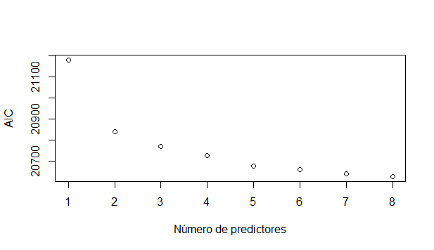
> plot(1:k, AIC, ylab="AIC", xlab="Número de predictores", axes=F)
> box(); axis(1,at=1:k); axis(2)
> rs$outmat[8,]
Jitterp Jitterabs Jitterrap JitterPPQ5 JitterDDP Shimmer
" " " " " " " " "*" " "
ShimmerdB ShimmerAPQ3 ShimmerAPQ5 ShimmerAPQ11 ShimmerDDA NHR
" " "*" " " "*" " " "*"
HNR RPDE DFA PPE
"*" "*" "*" "*"
En base a esto seleccionamos las 8 variables con mayor significacion estadistica en el modelo anterior:
> modelo2 <- lm(total_UPDRS ~ JitterDDP + ShimmerAPQ3 + ShimmerAPQ11 + NHR + HNR + RPDE + DFA + PPE, data = data.train)
> summary(modelo2)

Call:
lm(formula = total_UPDRS ~ JitterDDP + ShimmerAPQ3 + ShimmerAPQ11 +
NHR + HNR + RPDE + DFA + PPE, data = data.train)

Residuals:
Min 1Q Median 3Q Max
-27.0201 -6.7053 -0.9231 6.6758 25.0327

Coefficients:
Estimate Std. Error t value Pr(>|t|)
(Intercept) 59.85866 2.96668 20.177 < 2e-16 ***
JitterDDP 160.39212 34.43600 4.658 3.29e-06 ***
ShimmerAPQ3 -169.83862 27.41764 -6.195 6.35e-10 ***
ShimmerAPQ11 112.55676 18.77477 5.995 2.19e-09 ***
NHR -77.05261 8.84558 -8.711 < 2e-16 ***
HNR -0.50505 0.07054 -7.160 9.33e-13 ***
RPDE 19.86154 1.81727 10.929 < 2e-16 ***
DFA -52.53617 2.21024 -23.769 < 2e-16 ***
PPE 11.62985 2.79324 4.164 3.19e-05 ***
---
Signif. codes: 0 ‘***’ 0.001 ‘**’ 0.01 ‘*’ 0.05 ‘.’ 0.1 ‘ ’ 1

Residual standard error: 9.119 on 4655 degrees of freedom
Multiple R-squared: 0.1644, Adjusted R-squared: 0.163
F-statistic: 114.5 on 8 and 4655 DF, p-value: < 2.2e-16

> b<- regsubsets(total_UPDRS ~ Jitterp + Jitterabs + Jitterrap + JitterPPQ5 + JitterDDP + Shimmer + ShimmerdB + ShimmerAPQ3 + ShimmerAPQ5 + ShimmerAPQ11 + ShimmerDDA + NHR + HNR + RPDE + DFA + PPE, data = data.test)
> n <- nrow(data.test)
> (AIC <- n*log(rs$rss/n) + (2:p)*2)
[1] 25320.79 24890.96 24806.33 24750.01 24686.16 24663.32 24637.18 24622.24
> plot(1:k, AIC, ylab="AIC", xlab="Número de predictores", axes=F)
> rs$outmat[8,]
Jitterp Jitterabs Jitterrap JitterPPQ5 JitterDDP Shimmer
" " " " " " " " "*" " "
ShimmerdB ShimmerAPQ3 ShimmerAPQ5 ShimmerAPQ11 ShimmerDDA NHR
" " "*" " " "*" " " "*"
HNR RPDE DFA PPE
"*" "*" "*" "*"

> modelo2bis <- lm(total_UPDRS ~ JitterDDP + ShimmerAPQ3 + ShimmerAPQ11 + NHR + HNR + RPDE + DFA + PPE, data = data.test)
> summary(modelo2bis)

Call:
lm(formula = total_UPDRS ~ JitterDDP + ShimmerAPQ3 + ShimmerAPQ11 +
NHR + HNR + RPDE + DFA + PPE, data = data.test)

Residuals:
Min 1Q Median 3Q Max
-28.654 -7.436 -1.858 7.308 29.435

Coefficients:
Estimate Std. Error t value Pr(>|t|)
(Intercept) 64.05202 2.95804 21.654 < 2e-16 ***
JitterDDP 80.10567 27.34826 2.929 0.00341 **
ShimmerAPQ3 -165.03497 24.46408 -6.746 1.67e-11 ***
ShimmerAPQ11 98.70457 15.58573 6.333 2.58e-10 ***
NHR -45.71739 4.67206 -9.785 < 2e-16 ***
HNR -0.59557 0.07074 -8.419 < 2e-16 ***
RPDE 4.41151 1.79865 2.453 0.01421 *
DFA -42.57888 2.25402 -18.890 < 2e-16 ***
PPE 19.00598 2.59225 7.332 2.58e-13 ***
---
Signif. codes: 0 ‘***’ 0.001 ‘**’ 0.01 ‘*’ 0.05 ‘.’ 0.1 ‘ ’ 1

Residual standard error: 10.17 on 5866 degrees of freedom
Multiple R-squared: 0.09767, Adjusted R-squared: 0.09644
F-statistic: 79.37 on 8 and 5866 DF, p-value: < 2.2e-16

- Numero de variables utilizadas= 8
- R2 ajustado train= 0.163
- R2 ajustado test= 0.09644
- RMSE Train= [1] 9.110196
- RMSE Test= [1] 10.16342

3. Regresión por componentes principales.
Nota: Utilizar el mínimo de componentes razonable a la vista del gráfico de RMSE.

> modelo_pcr <- pcr(total_UPDRS ~ Jitterp + Jitterabs + Jitterrap + JitterPPQ5 + JitterDDP + Shimmer + ShimmerdB + ShimmerAPQ3 + ShimmerAPQ5 + ShimmerAPQ11 + ShimmerDDA + NHR + HNR + RPDE + DFA + PPE, data = data.train, scale = TRUE, validation = "CV")
> summary(modelo_pcr)
Data: X dimension: 4664 16
Y dimension: 4664 1
Fit method: svdpc
Number of components considered: 16

VALIDATION: RMSEP
Cross-validated using 10 random segments.
(Intercept) 1 comps 2 comps 3 comps 4 comps 5 comps 6 comps 7 comps 8 comps
CV 9.968 9.916 9.909 9.909 9.361 9.326 9.309 9.253 9.136
adjCV 9.968 9.915 9.909 9.908 9.359 9.325 9.309 9.247 9.135
9 comps 10 comps 11 comps 12 comps 13 comps 14 comps 15 comps 16 comps
CV 9.128 9.129 9.132 9.133 9.135 9.138 9.141 9.140
adjCV 9.127 9.128 9.131 9.131 9.133 9.137 9.139 9.138

TRAINING: % variance explained
1 comps 2 comps 3 comps 4 comps 5 comps 6 comps 7 comps 8 comps 9 comps
X 65.133 79.745 87.442 92.55 94.71 96.30 97.71 98.79 99.49
total_UPDRS 1.167 1.335 1.393 12.10 12.93 13.26 14.82 16.29 16.45
10 comps 11 comps 12 comps 13 comps 14 comps 15 comps 16 comps
X 99.68 99.82 99.90 99.97 100.00 100.00 100.00
total_UPDRS 16.45 16.46 16.47 16.47 16.47 16.47 16.53

> validationplot(modelo_pcr, val.type = "RMSEP")

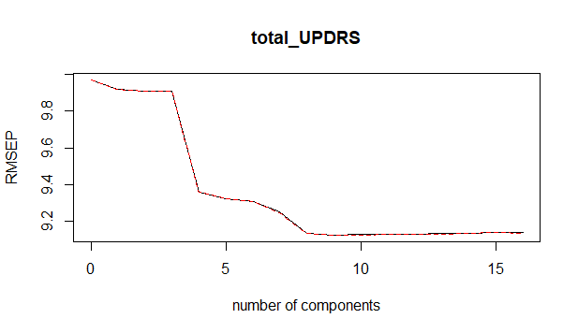
> which.min(x = modelo_pcr$validation$PRESS)
[1] 9

Es decir, el menor error se alcanza con 8 componentes principales (ya que el primero seria intercerpt).

> predcp<- predict(modelo_pcr, data.test, ncomp = 8)
> summary(predcp)
Min. 1st Qu. Median Mean 3rd Qu. Max.
-1.814 24.513 27.101 27.023 29.807 54.701

> modelo_pcrbis <- pcr(total_UPDRS ~ Jitterp + Jitterabs + Jitterrap + JitterPPQ5 + JitterDDP + Shimmer + ShimmerdB + ShimmerAPQ3 + ShimmerAPQ5 + ShimmerAPQ11 + ShimmerDDA + NHR + HNR + RPDE + DFA + PPE, data = data.test, scale = TRUE, validation = "CV")
> summary(modelo_pcrbis)
Data: X dimension: 5875 16
Y dimension: 5875 1
Fit method: svdpc
Number of components considered: 16

VALIDATION: RMSEP
Cross-validated using 10 random segments.
(Intercept) 1 comps 2 comps 3 comps 4 comps 5 comps 6 comps 7 comps
CV 10.7 10.64 10.64 10.63 10.42 10.3 10.3 10.29
adjCV 10.7 10.64 10.64 10.63 10.42 10.3 10.3 10.30
8 comps 9 comps 10 comps 11 comps 12 comps 13 comps 14 comps 15 comps
CV 10.19 10.17 10.17 10.17 10.17 10.17 10.17 10.17
adjCV 10.19 10.17 10.17 10.17 10.17 10.17 10.17 10.17
16 comps
CV 10.18
adjCV 10.18

TRAINING: % variance explained
1 comps 2 comps 3 comps 4 comps 5 comps 6 comps 7 comps 8 comps
X 70.382 80.837 88.590 93.371 95.304 96.697 97.776 98.787
total_UPDRS 1.078 1.258 1.324 5.352 7.551 7.551 7.672 9.574
9 comps 10 comps 11 comps 12 comps 13 comps 14 comps 15 comps
X 99.432 99.704 99.830 99.92 99.972 100.00 100.00
total_UPDRS 9.929 9.942 9.963 9.99 9.991 10.04 10.05
16 comps
X 100.00
total_UPDRS 10.06

> predcpbis<- predict(modelo_pcrbis, data.test, ncomp = 8)
> summary(predcpbis)
Min. 1st Qu. Median Mean 3rd Qu. Max.
16.12 26.84 28.93 29.02 31.03 55.41

Numero de componentes utilizados= 8
Varianza explicada con 8 componentes train= 98.79%
Varianza explicada con 8 componentes test= 98.78%
RMSE 8 componentes train= 9.13
RMSE 8 componentes test= 10.19

4. Partial least squares.
Nota: Utilizar el mínimo de componentes razonable a la vista del gráfico de RMSE.

> pls_modelo <- plsr(total_UPDRS ~ Jitterp + Jitterabs + Jitterrap + JitterPPQ5 + JitterDDP + Shimmer + ShimmerdB + ShimmerAPQ3 + ShimmerAPQ5 + ShimmerAPQ11 + ShimmerDDA + NHR + HNR + RPDE + DFA + PPE, data = data.train, validation="CV")
> plsCV <- RMSEP(pls_modelo,estimate="CV")
> plsCV
(Intercept) 1 comps 2 comps 3 comps 4 comps 5 comps
9.968 9.823 9.300 9.258 9.222 9.202
6 comps 7 comps 8 comps 9 comps 10 comps 11 comps
9.176 9.141 9.134 9.135 9.139 9.140
12 comps 13 comps 14 comps 15 comps 16 comps
9.142 9.142 9.141 9.141 9.141

> which.min(plsCV$val)
[1] 9
> plot(plsCV)
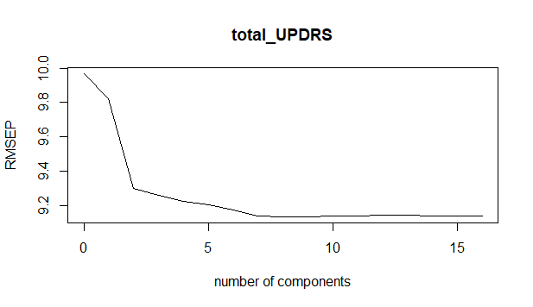
> pred<- predict(pls_modelo, data.test, ncomp = 8)
> summary(pred)
Min. 1st Qu. Median Mean 3rd Qu. Max.
0.9389 24.5503 27.1183 27.0639 29.7761 57.4185

> pls_modelobis <- plsr(total_UPDRS ~ Jitterp + Jitterabs + Jitterrap + JitterPPQ5 + JitterDDP + Shimmer + ShimmerdB + ShimmerAPQ3 + ShimmerAPQ5 + ShimmerAPQ11 + ShimmerDDA + NHR + HNR + RPDE + DFA + PPE, data = data.test, validation="CV")
> plsCVbis <- RMSEP(pls_modelobis,estimate="CV")
> plsCVbis
(Intercept) 1 comps 2 comps 3 comps 4 comps 5 comps
10.70 10.56 10.40 10.29 10.23 10.21
6 comps 7 comps 8 comps 9 comps 10 comps 11 comps
10.21 10.18 10.18 10.18 10.18 10.18
12 comps 13 comps 14 comps 15 comps 16 comps
10.18 10.18 10.18 10.18 10.18
- Numero de componentes utilizados= 8
- RMSE train= 9.134
- RMSE test= 10.18
5. Ridge regression.

> x<- model.matrix(total_UPDRS ~ Jitterp + Jitterabs + Jitterrap + JitterPPQ5 + JitterDDP + Shimmer + ShimmerdB + ShimmerAPQ3 + ShimmerAPQ5 + ShimmerAPQ11 + ShimmerDDA + NHR + HNR + RPDE + DFA + PPE, data = data.train)
> y<- data.train$total_UPDRS
> library(glmnet)
> modelo_ridge <- glmnet(x = x, y = y, alpha = 0)
> plot(modelo_ridge, xvar = "lambda", label = TRUE)
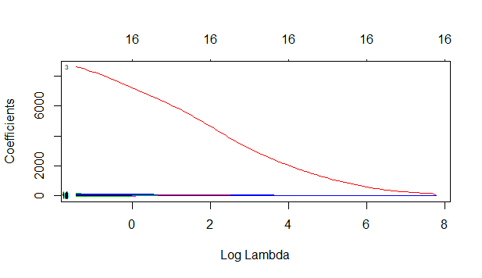
Vemos como solo unos de los coefiecientes se va haciendo mas pequeño a medida que aumenta lambda, lo que no es lo habitual. A continuacion veremos el valor de lambda que da lugar al mejor modelo.
> cv_error_ridge <- cv.glmnet(x = x, y = y, alpha = 0, nfolds = 10,type.measure = "mse")
> plot(cv_error_ridge)
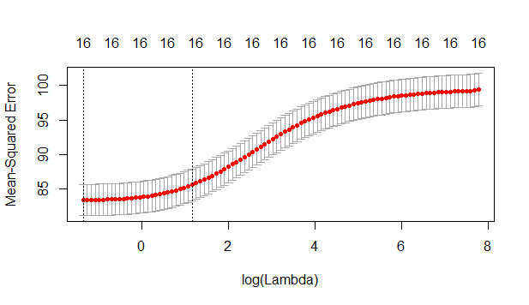
Veremos el valor de lambda con el que se consigue el menor error (primero), así como el valor lambda óptimo (segundo)
> cv_error_ridge$lambda.min ##menor error
[1] 0.2604092
> cv_error_ridge$lambda.1se ##valor optimo
[1] 3.210447

Así usamos este ultimo para nuestro modelo y vemos el valor de los coeficientes con este valor de lambda óptimo:

> modelo_final_ridge <- glmnet(x = x, y = y, alpha = 0, lambda = 3.210447)
> coef(modelo_final_ridge)
18 x 1 sparse Matrix of class "dgCMatrix"
s0
(Intercept) 43.32509352
(Intercept) .
Jitterp 14.30933093
Jitterabs 5741.50300198
Jitterrap -5.69710071
JitterPPQ5 11.12632217
JitterDDP -1.25483840
Shimmer -1.90148840
ShimmerdB 0.06023004
ShimmerAPQ3 -23.65431782
ShimmerAPQ5 -2.41779723
ShimmerAPQ11 43.74008277
ShimmerDDA -7.75590595
NHR -19.95654777
HNR -0.25001406
RPDE 15.09980810
DFA -31.66176486
PPE 7.97371188

6. LASSO.
> modelos_lasso <- glmnet(x = x, y = y, alpha = 1)
> plot(modelos_lasso, xvar = "lambda", label = TRUE)
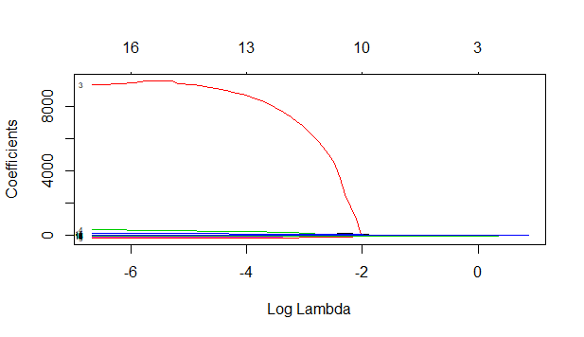

> cv_error_lasso <- cv.glmnet(x = x, y = y, alpha = 1, nfolds = 10)
> plot(cv_error_lasso)
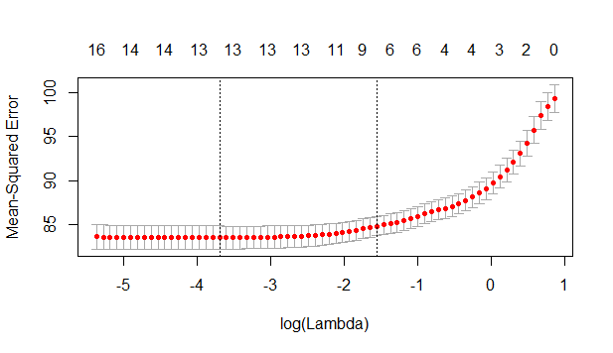
> cv_error_lasso$lambda.min
[1] 0.02485732
> cv_error_lasso$lambda.1se
[1] 0.211226
> modelo_final_lasso <- glmnet(x = x, y = y, alpha = 1, lambda = 0.211226)
> coef(modelo_final_lasso)
18 x 1 sparse Matrix of class "dgCMatrix"
s0
(Intercept) 47.08055281
(Intercept) .
Jitterp .
Jitterabs .
Jitterrap .
JitterPPQ5 .
JitterDDP .
Shimmer .
ShimmerdB .
ShimmerAPQ3 -0.03749783
ShimmerAPQ5 .
ShimmerAPQ11 16.49344421
ShimmerDDA -1.21732020
NHR -26.84661936
HNR -0.26492410
RPDE 19.19436562
DFA -40.94876706
PPE 12.19891840

7. ¿Cree necesario repetir estos métodos tomando la variable motor_UPDRS como respuesta?

El score motor constituye una sección del modelo total. Dado que el modelo total es estadisticamente significativo, cabria preguntarse si el motor tambien lo es o si el score global consigue la significacion gracias a la inclusion de un mayor numero de parametros que evaluan al paciente de una forma mas global. Para comprobarlo realizaremos solo el apartado 1:

> modelomotor <- lm(motor_UPDRS ~ Jitterp + Jitterabs + Jitterrap + JitterPPQ5 + JitterDDP + Shimmer + ShimmerdB + ShimmerAPQ3 + ShimmerAPQ5 + ShimmerAPQ11 + ShimmerDDA + NHR + HNR + RPDE + DFA + PPE, data = data.train)
> summary(modelomotor)

Call:
lm(formula = motor_UPDRS ~ Jitterp + Jitterabs + Jitterrap +
JitterPPQ5 + JitterDDP + Shimmer + ShimmerdB + ShimmerAPQ3 +
ShimmerAPQ5 + ShimmerAPQ11 + ShimmerDDA + NHR + HNR + RPDE +
DFA + PPE, data = data.train)

Residuals:
Min 1Q Median 3Q Max
-20.1764 -5.3249 -0.6371 5.6426 19.7431

Coefficients:
Estimate Std. Error t value Pr(>|t|)
(Intercept) 4.529e+01 2.433e+00 18.613 < 2e-16 ***
Jitterp 3.161e+02 1.926e+02 1.641 0.100905
Jitterabs -2.839e+04 8.335e+03 -3.406 0.000664 ***
Jitterrap -2.786e+04 3.843e+04 -0.725 0.468575
JitterPPQ5 -3.436e+02 2.174e+02 -1.581 0.113994
JitterDDP 9.356e+03 1.281e+04 0.730 0.465231
Shimmer 4.036e+01 7.822e+01 0.516 0.605918
ShimmerdB -1.557e-02 4.428e+00 -0.004 0.997194
ShimmerAPQ3 -5.240e+04 3.866e+04 -1.356 0.175277
ShimmerAPQ5 -7.334e+01 6.664e+01 -1.101 0.271156
ShimmerAPQ11 1.441e+02 2.967e+01 4.857 1.23e-06 ***
ShimmerDDA 1.741e+04 1.289e+04 1.351 0.176746
NHR -5.084e+01 7.820e+00 -6.502 8.74e-11 ***
HNR -3.942e-01 5.639e-02 -6.990 3.13e-12 ***
RPDE 9.364e+00 1.513e+00 6.190 6.54e-10 ***
DFA -3.712e+01 1.834e+00 -20.236 < 2e-16 ***
PPE 1.362e+01 2.703e+00 5.040 4.82e-07 ***
---
Signif. codes: 0 ‘***’ 0.001 ‘**’ 0.01 ‘*’ 0.05 ‘.’ 0.1 ‘ ’ 1

Residual standard error: 7.128 on 4647 degrees of freedom
Multiple R-squared: 0.1464, Adjusted R-squared: 0.1434
F-statistic: 49.8 on 16 and 4647 DF, p-value: < 2.2e-16

Ejercicio 2

Con la base de datos data.train del ejercicio anterior y el modelo OLS hacer un análisis de los residuos para detectar incumplimientos de las condiciones de un modelo lineal.

1. Investigar si los errores tienen varianza constante.
> car::ncvTest(modelo1)
Non-constant Variance Score Test
Variance formula: ~ fitted.values
Chisquare = 87.96347, Df = 1, p = < 2.22e-16

Tenemos un p valor <0.05 por lo que podemos rechazar la hipotesis nula de que la varianza de los residuos es constante e inferir que la heteroscedasticidad esta presente.

2. Estudiar la hipótesis de normalidad. Hacer un test de Jarque-Bera.
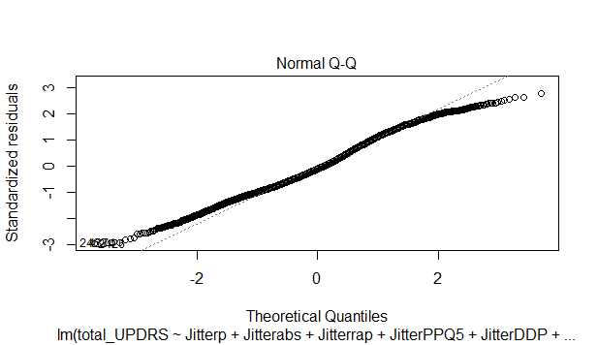
> jarque.bera.test(residuosols)

Jarque Bera Test

data: residuosols
X-squared = 73.518, df = 2, p-value < 2.2e-16

Se rechaza la hipotesis nula de normalidad de los residuos, lo que concuerda con el gráfico de normalidad.
Dibujar un gráfico de densidad estimada por kernel de los residuos (también se puede hacer un histograma) y añadir la densidad normal con los parámetros estimados por el modelo lineal. Comentar el resultado.

> density(residuosols,kernel="epanechnikov")

Call:
density.default(x = residuosols, kernel = "epanechnikov")

Data: residuosols (4664 obs.); Bandwidth 'bw' = 1.513

x y
Min. :-31.4024 Min. :0.00000
1st Qu.:-16.1053 1st Qu.:0.00121
Median : -0.8083 Median :0.01246
Mean : -0.8083 Mean :0.01633
3rd Qu.: 14.4887 3rd Qu.:0.02818
Max. : 29.7858 Max. :0.04294

> plot(density(residuosols,kernel="epanechnikov"))
> curve(dnorm(x, mean(residuosols), sd(residuosols)), col = 2, lty = 2, lwd = 2, add=T)
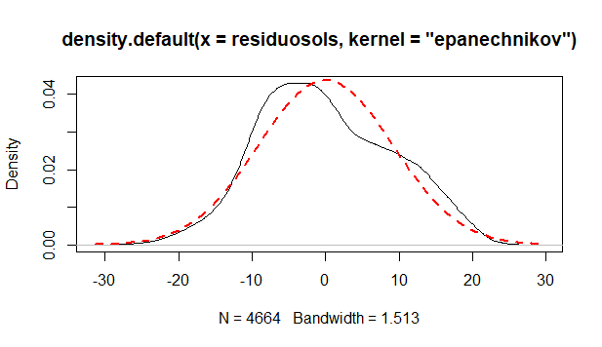

Calcular la asimetría y la kurtosis de los residuos, compararla con la de la ley normal y decidir el tipo de distribución que tienen los residuos. ¿Qué transformación podemos hacer para que la distribución de los residuos sea “más” normal?

> skewness(residuosols)
[1] 0.1673381
> kurtosis(residuosols)
[1] 2.483957

Ademas podriamos aplicar el siguiente codigo:
gvlma(x = modelo1)

Value p-value Decision
Global Stat 128.834 0.000e+00 Assumptions NOT satisfied!
Skewness 21.767 3.079e-06 Assumptions NOT satisfied!
Kurtosis 51.751 6.301e-13 Assumptions NOT satisfied!
Link Function 51.720 6.402e-13 Assumptions NOT satisfied!
Heteroscedasticity 3.596 5.791e-02 Assumptions acceptable.

Podemos decir que la distribucion se llama leptocurtica, hay una mayor concentracion de los datos en torno a la media. No podemos asumir simetria ni kurtosis. `Podriamos hacer una transformacion logarítmica de los datos para que se aproximen a una distribucion normal.

3. ¿Cuales son los puntos con influencia potencial (leverage )? Hacer un gráfico.
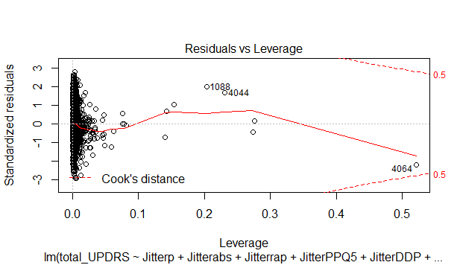
Segun el gráfico los puntos con influencia potencial seran 1088, 4044 y 4064.
4. Con los residuos studentizados externamente (jacknife residuals ), ¿cuales son los valores atípicos (outliers)? Calcular cuales son estadísticamente relevantes por el método de Bonferroni.
> stud <- rstudent(modelo1)
> head(sort(stud,decreasing=TRUE))
4040 4082 4060 4103 2867 4145
2.774326 2.638406 2.628356 2.583752 2.525262 2.479007
> gll <- length(modelo1$fitted.values)-(length(modelo1$coefficients))-1
> abs(qt(0.05/(length(modelo1$fitted.values)*2),gll))
[1] 4.40694 --> Este sería el valor crítico, por lo tanto no encontramos outliers.

5. Hallar los puntos influyentes según la distancia de Cook. Dibujar un gráfico.
¿Cuales son los 3 puntos más influyentes? ¿Coincide alguno con ser atípico o con alto leverage?
> cook <- cooks.distance(modelo1)
>
> head(sort(cook,decreasing=TRUE))
4064 1088 4044 1113 2468 2422
0.318338478 0.059436413 0.048097060 0.011011959 0.006099146 0.005823259

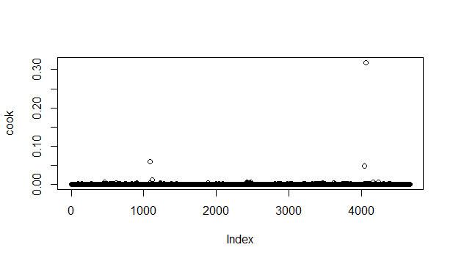
Los 3 puntos ms influyentes son 4064, 1088 y 4044, que coinciden con los que destacan n el gráfico de leverage
6. Detectar si hay problemas de colinealidad.

> vif(modelo1)
Jitterp Jitterabs Jitterrap JitterPPQ5 JitterDDP Shimmer
6.866369e+01 6.543889e+00 9.201067e+05 2.964221e+01 9.202938e+05 1.996731e+02
ShimmerdB ShimmerAPQ3 ShimmerAPQ5 ShimmerAPQ11 ShimmerDDA NHR
5.174479e+01 1.512517e+07 5.585492e+01 1.870013e+01 1.512630e+07 4.983426e+00
HNR RPDE DFA PPE
4.254011e+00 2.103325e+00 1.682842e+00 4.728052e+00

Puede que existan problemas de colinealidad con Jitterrap y JitterDDP ya que tienen indices muy elevados cercanos a 10. Ademas hay multiples indices entre 5 y 10 lo que nos indica que probablemente haya problemas de colinealidad, lo que comprobamos gráficamente.

> corrplot.mixed(corr = cor(data.train[,c("Jitterp", "Jitterabs", "Jitterrap", "JitterPPQ5","JitterDDP", "Shimmer", "ShimmerdB", "ShimmerAPQ3", "ShimmerAPQ5", "ShimmerAPQ11", "ShimmerDDA", "NHR", "HNR", "RPDE", "DFA", "PPE")], method = "pearson"))

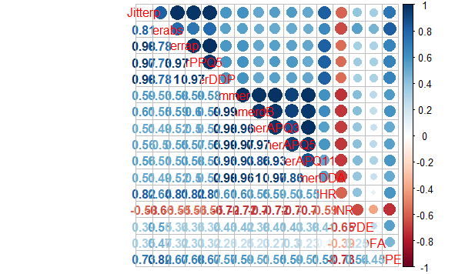
En este gráfico observamos fuertes correlaciones positivas entre los diferentes Jitter; y entre los diferentes Shimmer.
> par(mfrow = c(2,2))
> plot(x = data.train$Jitterp, y = data.train$Jitterabs, pch = 20)
> plot(x = data.train$Jitterp, y = data.train$Jitterrap, pch = 20)
> plot(x = data.train$ShimmerdB, y = data.train$ShimmerAPQ3, pch = 20)
> plot(x = data.train$ShimmerAPQ5, y = data.train$Shimmer, pch = 20)
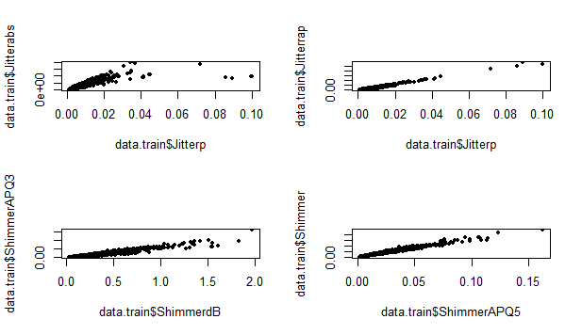
Ejercicio 3
Seguimos con la base de datos de los ejercicios anteriores. En esos ejercicios hemos visto que el modelo OLS presenta algunas dificultades. Para superarlas podemos estudiar otros métodos.

1. Eliminar de la base de datos los 3 puntos más influyentes y volver a calcular los modelos del
ejercicio 1. Mostrar en una tabla los RMSE del grupo de prueba (test ) para cada uno de los
modelos con y sin los puntos influyentes.
Nota: En este apartado sólo hay que mostrar la tabla.

> data.trainbis <- data.train[-c( 4064, 1088, 4044),]
> data.testbis <- data.test[-c( 4064, 1088, 4044),]

RMSE | CON OUTLIERS | SIN OUTLIERS
MODELO 1 | 10.14711 | 10.14426
MODELO 2 AIC | 10.16342 | 10.16345
MODELO 3 PC | 10,19 | 10,2
MODELO 4 PLS | 10,18 | 10,18
RIDGE
LASSO

3. Dados los problemas observados con los residuos del modelo OLS, podemos probar un método robusto como el de Huber o el Least trimmed squares (LTS).

> modelo_huber <- rlm(total_UPDRS ~ Jitterp + Jitterabs + Jitterrap + JitterPPQ5 + JitterDDP + Shimmer + ShimmerdB + ShimmerAPQ3 + ShimmerAPQ5 + ShimmerAPQ11 + ShimmerDDA + NHR + HNR + RPDE + DFA + PPE, data = data.train)
> summary(modelo_huber)

Call: rlm(formula = total_UPDRS ~ Jitterp + Jitterabs + Jitterrap +
JitterPPQ5 + JitterDDP + Shimmer + ShimmerdB + ShimmerAPQ3 +
ShimmerAPQ5 + ShimmerAPQ11 + ShimmerDDA + NHR + HNR + RPDE +
DFA + PPE, data = data.train)
Residuals:
Min 1Q Median 3Q Max
-26.8215 -6.5754 -0.7888 6.8563 25.4286

Coefficients:
Value Std. Error t value
(Intercept) 61.6270 3.2810 18.7830
Jitterp 5.2448 259.7436 0.0202
Jitterabs 1874.7373 11237.8266 0.1668
Jitterrap -14570.6628 51814.8611 -0.2812
JitterPPQ5 -57.8499 293.1040 -0.1974
JitterDDP 5056.8870 17273.1875 0.2928
Shimmer -13.1263 105.4644 -0.1245
ShimmerdB -2.2202 5.9702 -0.3719
ShimmerAPQ3 -80631.1749 52119.3883 -1.5470
ShimmerAPQ5 18.5009 89.8559 0.2059
ShimmerAPQ11 132.4234 39.9983 3.3107
ShimmerDDA 26822.8293 17373.7227 1.5439
NHR -81.9023 10.5432 -7.7683
HNR -0.5301 0.0760 -6.9720
RPDE 19.3853 2.0398 9.5038
DFA -53.9871 2.4730 -21.8304
PPE 10.8308 3.6439 2.9723

Residual standard error: 9.928 on 4647 degrees of freedom
> modelo_lts<- ltsreg(total_UPDRS ~ Jitterp + Jitterabs + Jitterrap + JitterPPQ5 + JitterDDP + Shimmer + ShimmerdB + ShimmerAPQ3 + ShimmerAPQ5 + ShimmerAPQ11 + ShimmerDDA + NHR + HNR + RPDE + DFA + PPE, data = data.train)
> modelo_lts
Call:
lqs.formula(formula = total_UPDRS ~ Jitterp + Jitterabs + Jitterrap +
JitterPPQ5 + JitterDDP + Shimmer + ShimmerdB + ShimmerAPQ3 +
ShimmerAPQ5 + ShimmerAPQ11 + ShimmerDDA + NHR + HNR + RPDE +
DFA + PPE, data = data.train, method = "lts")

Coefficients:
(Intercept) Jitterp Jitterabs Jitterrap JitterPPQ5 JitterDDP
1.802e+02 -4.935e+02 3.712e+05 5.175e+03 -2.062e+02 -2.372e+03
Shimmer ShimmerdB ShimmerAPQ3 ShimmerAPQ5 ShimmerAPQ11 ShimmerDDA
2.177e+03 -1.737e+01 3.003e+05 -3.747e+02 -5.303e+02 -1.009e+05
NHR HNR RPDE DFA PPE
-2.640e+02 -2.655e+00 -5.134e+01 -1.041e+02 -1.330e+01

Scale estimates 11.74 10.95

4. Calcular el método PLS con la función plsreg1() del paquete plsdepot. Dar el RMSE para el
grupo de prueba.

> nc<- 8
> trainpls<- plsreg1(data.train[,c(7:22)], data.train[,6],comps=nc, crosval=TRUE)
> names(trainpls)
[1] "x.scores" "x.loads" "y.scores" "y.loads" "cor.xyt" "raw.wgs"
[7] "mod.wgs" "std.coefs" "reg.coefs" "R2" "R2Xy" "y.pred"
[13] "resid" "T2" "Q2" "y"
> trainpls$Q2
PRESS RSS Q2 LimQ2 Q2cum
1 4493.648 4663.000 0.0363182357 0.0975 0.03631824
2 4024.520 4490.255 0.1037214581 0.0975 0.13627271
3 3976.040 4014.474 0.0095739078 0.0975 0.14454196
4 3912.428 3971.679 0.0149184338 0.0975 0.15730405
5 3902.530 3903.615 0.0002779274 0.0975 0.15753826
6 3903.067 3899.099 -0.0010175940 0.0975 0.15668098
7 3903.068 3896.035 -0.0018052675 0.0975 0.15515856
8 3902.068 3895.547 -0.0016738857 0.0975 0.15374439

> testpls<- plsreg1(data.test[,c(7:22)], data.test[,6],comps=nc, crosval=TRUE)
> testpls$Q2
PRESS RSS Q2 LimQ2 Q2cum
1 5760.378 5874.000 0.0193432491 0.0975 0.01934325
2 5437.706 5757.628 0.0555650460 0.0975 0.07383349
3 5369.844 5429.930 0.0110656513 0.0975 0.08408212
4 5312.123 5363.966 0.0096649481 0.0975 0.09293442
5 5301.138 5303.745 0.0004915178 0.0975 0.09338026
6 5295.810 5296.747 0.0001770176 0.0975 0.09354075
7 5301.102 5289.455 -0.0022019326 0.0975 0.09154479
8 5299.846 5287.862 -0.0022662051 0.0975 0.08948604

